Name : M.Sreekar

Reg no : 127156098

Roll no : 31 ( sec-F )

Course : Data Analytics in Health Care (DAHC)

Ex - 6

Implement rule based, pattern-based and machine learning algorithms for information extraction on clinical text and generate structured datasets.

Aim : To implement three different methods(rule-based, pattern-based, and machine learning) for extracting structured data (Patient ID, Age, Diagnosis) from clinical text and generate structured datasets.

Objective :

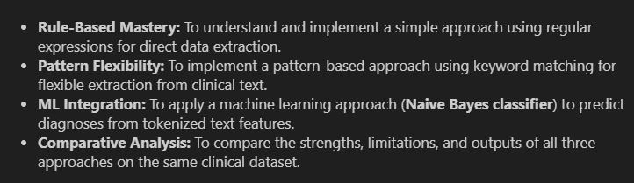

Procedure :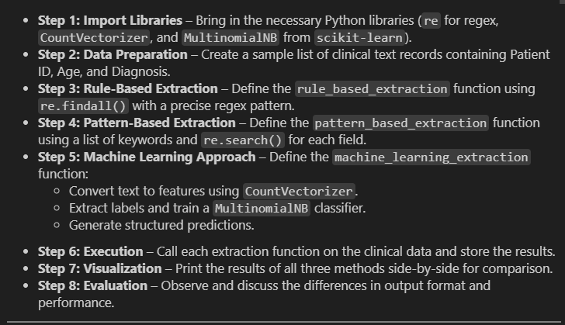

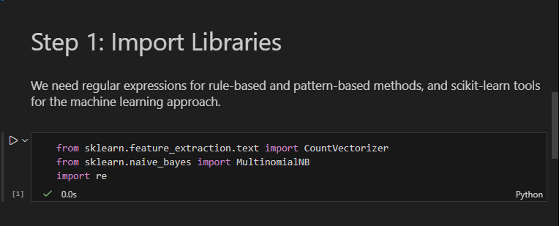

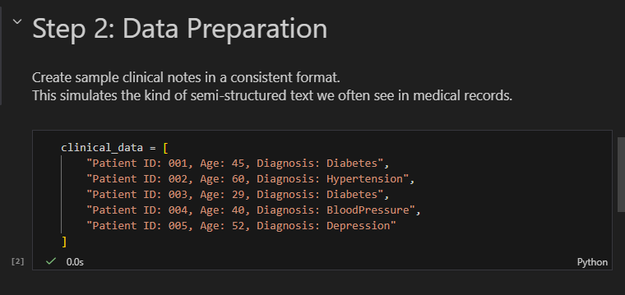

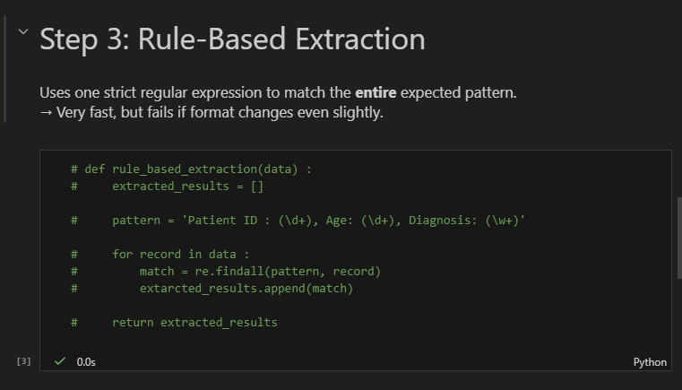

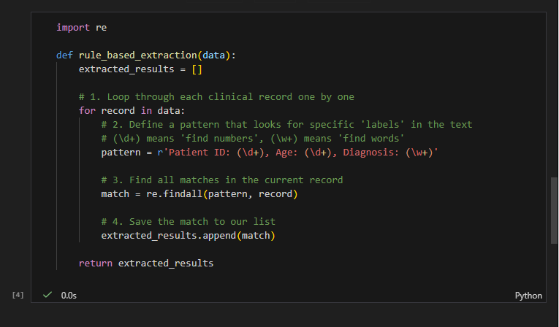

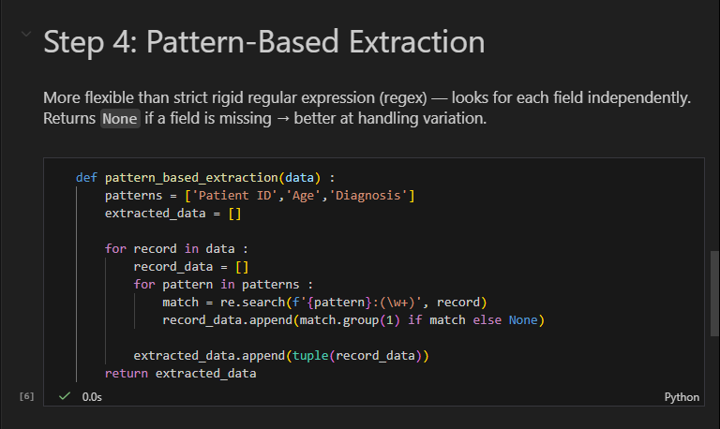
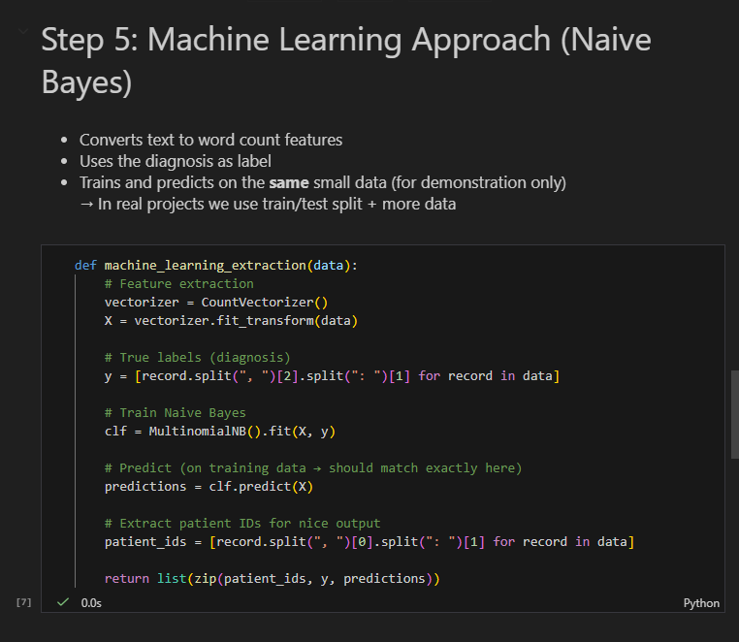

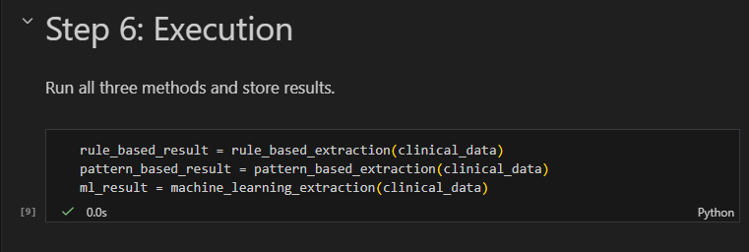
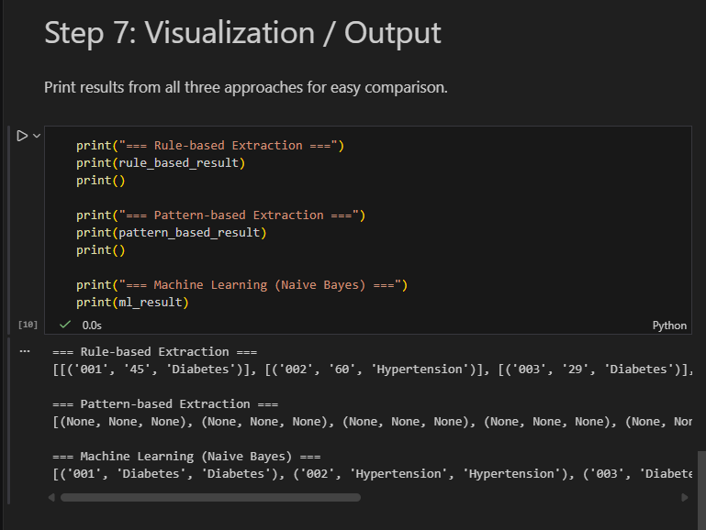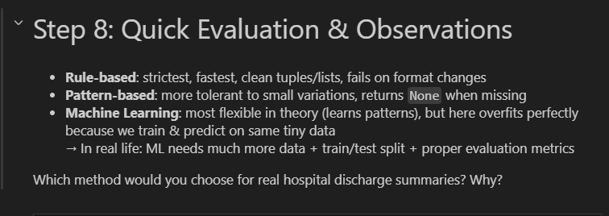

EXTRA 👍
